AWS CloudWatch

CloudWatch is the monitoring service of AWS. It enables you to monitor metrics of resources and applications that run on AWS as well as on-premise servers. It also lets you get logs, set alarms, trigger events and analyze utilization.

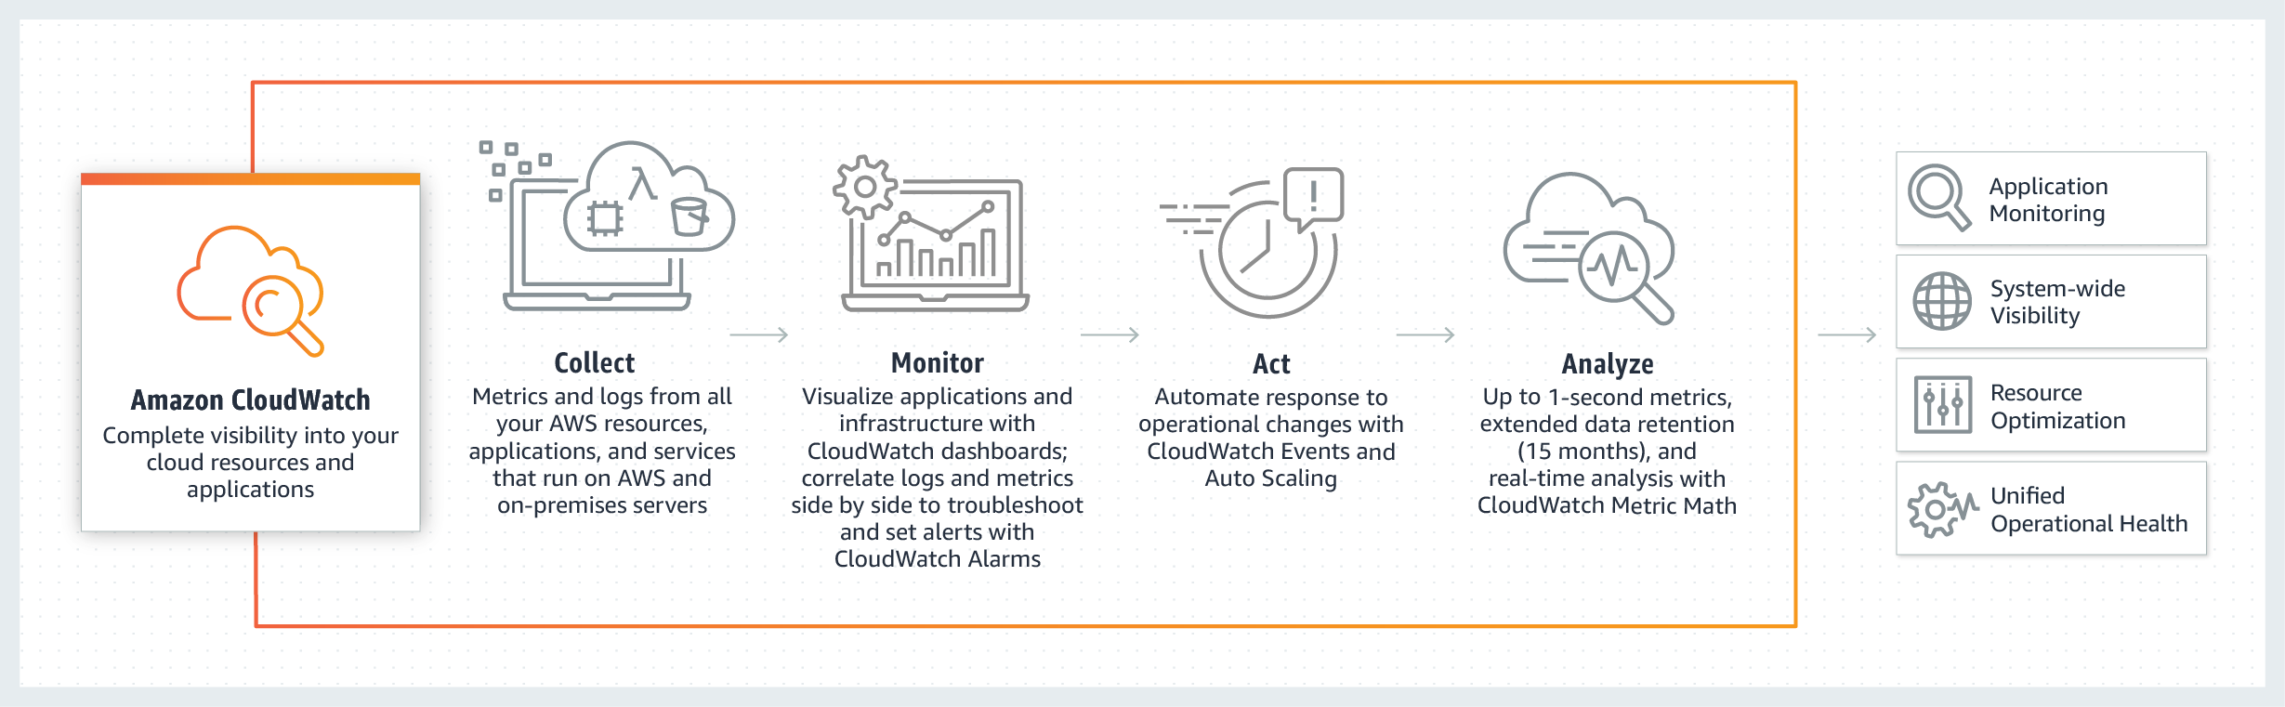

CloudWatch collects metrics and logs from AWS resources, applications and services running on AWS and on-premises servers. You can visualize applications and infrastructure using **Dashboards**; correlate logs and metrics side by side to troubleshoot and set **Alarms**. It also enables you to automate response to operational changes with **Events** and **Auto-Scaling**. You can leverage metrics (up to 1 second), extended data retention (15 months) and real-time analysis with **Metric Math**.

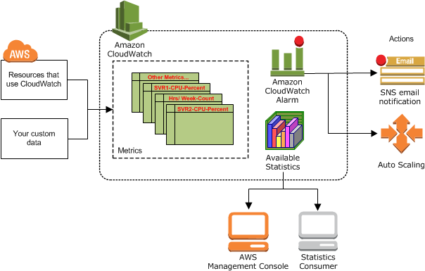

Basic Components of CloudWatch

**Metrics:** Metrics are the measurable data about your resources, apps or services like EC2 instance CPU utilization or the number of objects in an S3 bucket.

**Dashboards:** Dashboards enable you to create graphs and visualize your cloud resources and applications according to your needs. You can leverage dashboards as customizable home pages in the CloudWatch console to view metrics, logs and alarms.

**Alarms:** Alarms enables you to monitor CloudWatch metrics and to receive notifications if the metrics fall outside of the thresholds (higher or lower) that you set.

**Logs:** Logs let you monitor, store, and access your log files from AWS or other resources. It also allows you to centralize these logs for querying and analyzing.

**Events:** An event indicates changes in your AWS environment. AWS resources can generate events when their state changes, or you can create rules that self-trigger on an automated schedule. For example, you can receive an email via SNS if one of your EC2 instances goes to the "stop" state.

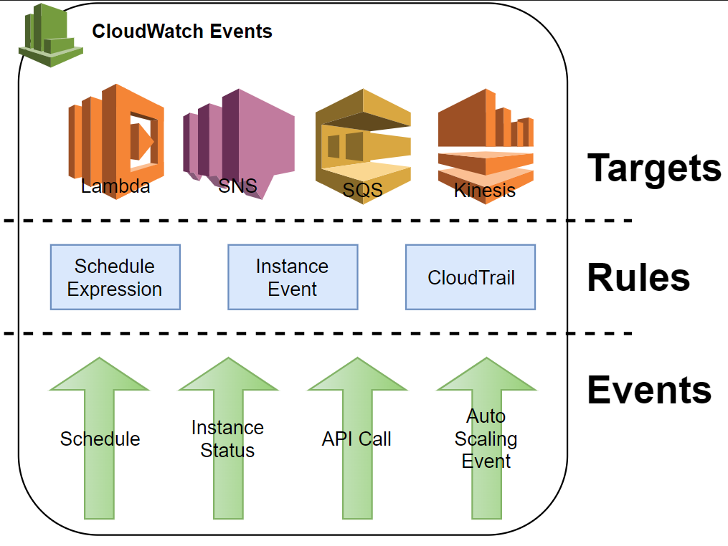

### Accessing and Pricing

**Accessing:**

You can access CloudWatch using any of the following methods:

* Amazon CloudWatch console – <https://console.aws.amazon.com/cloudwatch/>
* AWS CLI
* CloudWatch API – For more information, see the [Amazon CloudWatch API Reference](https://docs.aws.amazon.com/AmazonCloudWatch/latest/APIReference/Welcome.html).
* AWS SDKs – For more information, see [Tools for Amazon Web Services](https://aws.amazon.com/tools/).

**Pricing:**

CloudWatch doesn't require any up-front commitment or minimum fee. As many other Amazon Web Services, you simply pay for what you use and will be charged at the end of the month for your usage. Pricing varies by region.

Many services vend metrics for free, so that you can leverage within **Free Tier**:

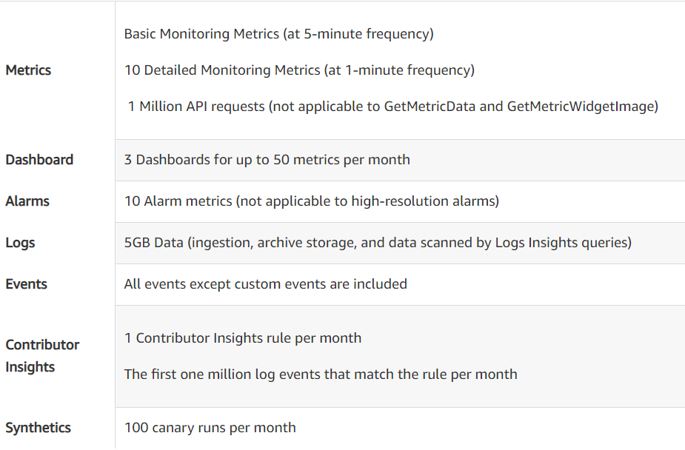

Check [here](https://aws.amazon.com/cloudwatch/pricing/) for more information about CloudWatch Pricing.

## **Introduction to CloudFront**

CloudFront is the Content Delivery Network (CDN) of AWS. Basically, it is a globally distributed network located on different geographical places. The aim of this service is to provide faster distribution to the dynamic or the static web contents. World-wide distributed data centers which are called edge locations are the backbone of CloudFront.

AWS CloudFront has a world-wide network of 225+ Points of Presence (PoP) consisting of 215+ Edge Locations and 12 Regional Mid-tier Caches. These facilities are spread over 89 cities across 46 countries (March 2021). The image above shows The Amazon CloudFront Global Edge Network.

You can check the link below to see the Edge Locations and the Regional Edge Caches all around the world.

### How Does CloudFront Work?

### 

When a request is sent from an end user to the origin server, this request has to travel through the entire connecting network from the user's computer to the origin server. The response of the origin server (i.e. image.png) has to cover the same distance back to the user's computer as well.

Considering the vast number of users in a region trying to fetch/send data from/to servers in different regions, this process inevitably causes latency and redundant traffic.

CloudFront's world-wide distributed edge locations cache requested data and deliver it to the end users without the necessity of going back and forth between users and servers.

### Accessing CloudFront

AWS enables you to access CloudFront via:

* **AWS Management Console**: You can use Management Console to easily access CloudFront like many other services.
* **AWS Command Line Interface**: You can use also CLI to access CloudFront. Please check this link if you need more information about [AWS CLI](https://docs.aws.amazon.com/cli/latest/userguide/cli-chap-welcome.html).
* **AWS Tools for Windows PowerShell**: As well as CLI, AWS lets you access CloudFront using Windows PowerShell. Here is the link for more information about [AWS Tools for Windows PowerShell](https://docs.aws.amazon.com/powershell/latest/userguide/pstools-welcome.html).
* **AWS SDKs**: You can use SDKs to access CloudFront. AWS provides SDKs for many programming languages. To see these SDKs and programming languages check [Tools for Amazon Web Services](https://aws.amazon.com/tools).
* **CloudFront API**: If you can't find an SDK which AWS provides for your programming language, see [Amazon CloudFront API Reference](https://docs.aws.amazon.com/cloudfront/latest/APIReference/Welcome.html) for information about making API requests and API actions.

CloudFront Pricing

CloudFront offers three options for pricing:

* Free Tier
* On-demand
* Discounted Pricing

Pricing varies depending on region and usage. Thus, to be more cost effective setup your configuration regarding your goal, methods, end users and geographic locations. You can check the link below to see AWS pricing in detail.

[AWS CloudFront Pricing](https://aws.amazon.com/cloudfront/pricing/?nc=sn&loc=3)

You can also estimate your monthly bill using the [AWS Simple Monthly Calculator](https://calculator.s3.amazonaws.com/index.html).

